School Council Agenda

September 21, 2020

Created By: Brandi M. James, Assistant Principal

* Elect a secretary/parliamentary
* School Improvement Plan
* Our current goals 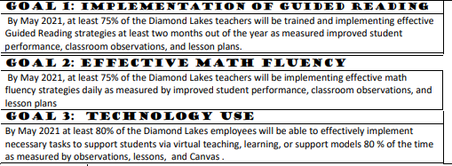
* Current mission - **We will provide a safe, standards based learning environment**

**that ensures a growth mindset so all students**

**reach their learning potential.**

* Vision
* Survey prepared for each member to give feedback back on each goal, the mission, and make suggestions for the vision.
* Title 1 Funds
* Discuss electronic survey prepared to go out as well as an additional survey for suggestions for fundraising and school support ideas from our community partners.